Design document

Purpose of website
The purpose of this website is to provide visitors information about movies and build a platform for them to share their views, and buy DVDs.
Site modules
This website consists of following modules.
- Home Page – news movies
- Search – a search engine providing information on movie production, reviews, comments, ranks, pictures, stories, etc.
- Rating system – users rate movies, write comments, share their reviews and reflections
- DVD – a platform for users to buy DVDs
- User account – manage user’s personal information, favorite movies, DVD shopping, etc.
Application architecture
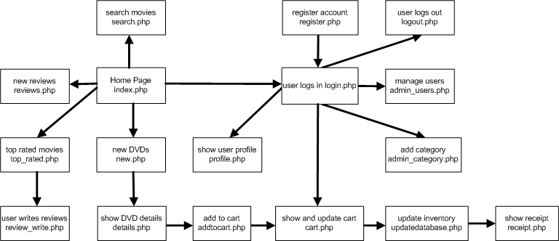

Database E-R model
